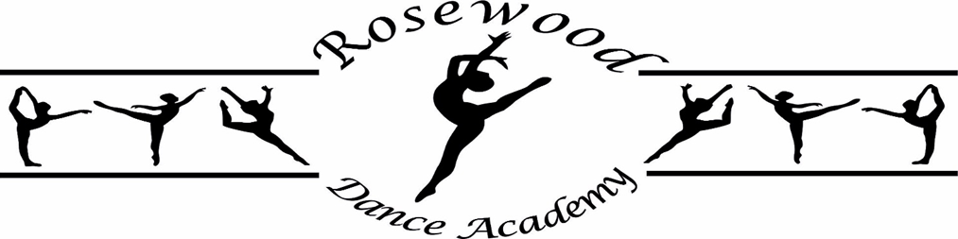

Ballet, Modern Theatre Jazz Dance Registration Form.

Parent/Guardian Name

Child’s Name

Date of Birth Year Group

Any Medical Condition?

Class Attending?

Will your child need collecting by Miss Rose Elwood at the end of the school day and escorted to the School Hall, School Gym or Scout Hut? Please sign your permission here:

Who will collect your child at the end of their dance classes?
If it is not the name/s stated above, please state the name and who they are? (e.g.grandparent)

Address

Post Code

Emergency Numbers, Home:

Mobile

Email

From time to time, I like to update my website and Facebook page with photographs of pupils and events that may take place.
Please sign your acceptance here:

